GUIDE TO USING THE REQUEST FOR QUOTE FORM

In accordance with PPS-47-0270 Intermediate Procurements, The Request for Quote Form can be used for obtaining quotes for your material purchases between $25,000.00 and $250,000.00. When obtaining quotes in this dollar range quotes must be sought from at least three vendors who can reasonably fulfill your requirement.

Fill in necessary information as provided in the example below. Complete all information in gray, except the portion designated for the Quote Provider:

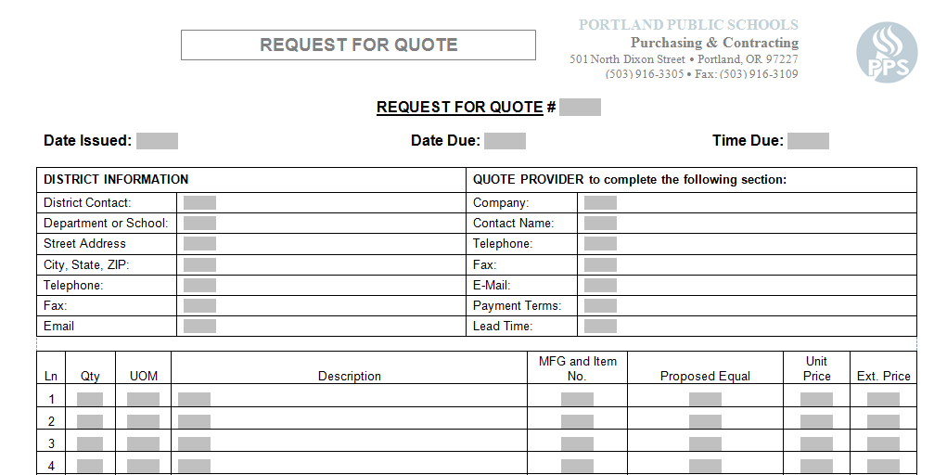

Tips when issuing quotes:

- Sending quotes via e-mail is preferential, this way it is documented that all suppliers receive the quote at the same time.
- The due date for quotes should provide sufficient time for the supplier to respond to your request. Five business days is typically sufficient for one time material requirements.
- Quotes received after the date due and time due can not be accepted.
- The quote provider who is lowest in overall price and is able to fully meet your needs must be awarded.
- Use the description field to elaborate on the most important quality levels of the product you are seeking to purchase as referenced in the Equal to MFG and Item No. column, similar to the example above.

